**CareersNet meeting discusses how to support careers post-2020**

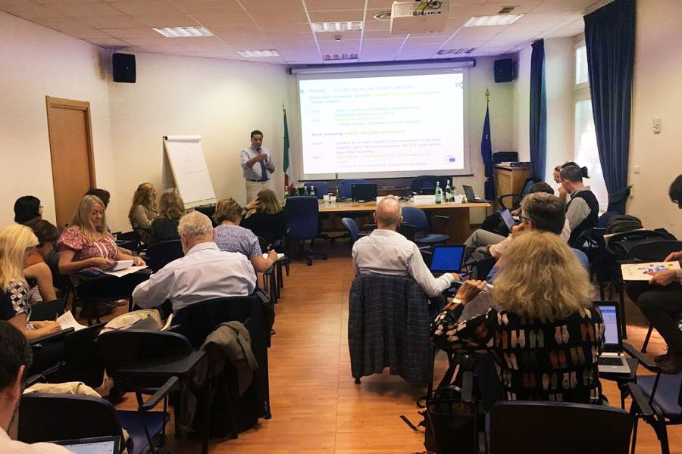

**Image copyright:**

© Cedefop, 2019/Alessia de Martino

**Independent career development experts from across Europe, representatives from the European Commission and the European Training Foundation met on 19 and 20 September in Rome to debate how people will be supported in their careers in the post-2020 period.**

The meeting of Cedefop’s CareersNet discussed how digital technologies, artificial intelligence and labour market information are changing guidance services and career education at school. Participants examined innovative practices, current challenges and actions to prioritise at national and EU levels.

Conclusions highlighted the network’s important role in the development of strategies to:

* consolidate guidance as a socioeconomic right with a clear reflection in the development of e-government;
* support the implementation of career education and career learning in schools, enterprises and communities;
* promote integrated services which can support individuals during their full lifecycles, pooling the efforts of employment services, social security, social partners and other stakeholders.

An important part of the meeting was dedicated to analysing current strategies to support adult learning and careers. Issues debated included the results of Cedefop’s forthcoming study on validation of skills and guidance, regional governance, vouchers and other quasi-market arrangements.

The host organisations, the Italian Ministry of Labour and the National Agency for Active labour market policies (ANPAL), presented current national initiatives to upskill adults. The new ‘citizen income scheme’, which combines financial support to vulnerable groups with activation measures, attracted high interest.

CareersNet is also the group of experts behind Cedefop’s forthcoming European inventory of lifelong guidance systems, which will include the EU, EEA and EU-accession countries.

The Rome event was part of the European vocational skills week 2019, of which Cedefop is a partner.